SOA Extension for BlackBerry

What is the Service Oriented Architecture (SOA)
The service oriented architecture is the new way to build extensions for WebWorks. JavaScript extensions have adopted a client-server model where they request data from their native implementation in a RESTful manner.

Why adopt the Service Oriented Architecture
The SOA architecture improves performance, accessibility and maintainability of an extension.

Decouples JavaScript implementation from lower level native service
SOA extensions are loosely coupled to the native implementation of the API because they rely on RESTful requests to transport data. This gives a developer the option of moving business logic to the JavaScript layer where they gain a productivity boost from the higher level language. It also improves maintainability and readability. Performance improvements from the browser’s JavaScript engine also extend to WebWorks extensions as soon as they are available.

Allows support for RESTful APIs
The native service can be loaded and service external requests to its URI independent of the JavaScript layer.

Easier to port extensions between platforms
The new architecture relies on moving the business logic of an extension to the JavaScript layer, which is portable across all WebWorks supported platforms. This decreases API fragmentation significantly.

How does the SOA work?
A JavaScript extension is divided into three layers.
The JavaScript Layer contains the business logic of an API. All work that can be done in JavaScript, such as parameter validation and data processing should be done here. This layer is common across all WebWorks platforms.
The JavaScript layer makes calls to the native implementation through the Transport Layer which is responsible for translating a JavaScript call into an XML Http Request and sending it to the appropriate native implementation URI. This layer is WebWorks platform specific as differences between calling mechanisms may exist.
The XHR request is received and serviced by the Native Layer, written in Java on the BlackBerry and ActionScript on PlayBook. It is responsible for validating the request against the white list and routing it to the appropriate Java Extension that will service it.
The layers communicate through XHR requests to a special URI and data is JSON-encoded for portability. Regardless of how each device implements an API, the developers get a consistent interface across all platforms.

How to create a simple property in SOA for BlackBerry

As a sample, we’ll create a simple extension that contains a property, a function and an event. By the end of it, we should have a skeleton of code that can be reused as the basis of more complex extensions with minimal modifications.
For added shock value, the property and function will return “Hello World”.

Design the procedural API
Since we are looking to create something that uses the three building blocks of APIs, it will be straightforward: we’ll need an example of each. To avoid potential conflict, we’ll stash them in a namespace of our choosing; the more unique, the better. Ours will be blackberry.helloworld.text.
It will look something like this:
blackberry.helloworld.CONSTANT = 42;
blackberry.helloworld.text = “Hello World”; (this is read-only)
blackberry.helloworld.echo() : “Hello World”;
blackberry.helloworld.onRandomEcho(callback : function);

Implement a Quick Test Page for it
The next step is to create a simple HTML test page that will exercise our API. This will initially allow us to test that all the pieces of the extension have been connected correctly. As development proceeds, additional properties become “available”, giving an indication of the readiness of the API at every step.
In this case we will have a button that will display the contents of our API elements when clicked. We could have looped through the blackberry.helloworld object and enumerated its members, but breaking them out individually is more expressive.
<!DOCTYPE html PUBLIC "-//W3C//DTD HTML 4.01 Transitional//EN" "http://www.w3.org/TR/html4/loose.dtd">
<html>
<head>
<meta http-equiv="Content-Type" content="text/html; charset=UTF-8">
<meta name="viewport" id="viewport" content="height=device-height,user-scalable=no" />
<title>HelloWorld API TestApp</title>
<script>
function sayHelloWorld() {
alert('Constant time! blackberry.helloworld.CONSTANT = ' + blackberry.helloworld.CONSTANT);

alert('Property time! blackberry.helloworld.text = ' + blackberry.helloworld.text);

alert('Function time! blackberry.helloworld.echo() returns ' + blackberry.helloworld.echo());

blackberry.helloworld.onRandomEcho(function() { alert('Random event happened!'); });
}
</script>
</head>
<body>
<button type="button" onclick='sayHelloWorld();'>Click me to see the property!</button>
</body>
</html>

Create the directory structures
We will take a quick break from development to separate our application files from the extension API that it uses.
An extension API must be placed in the ext folder of the BlackBerry Packager installation. It has a JavaScript component, a Java component, and a descriptor file, library.xml, which links the two at package time.
We’ll place our API in the sample subfolder, which will contain java and js subfolders respectively.
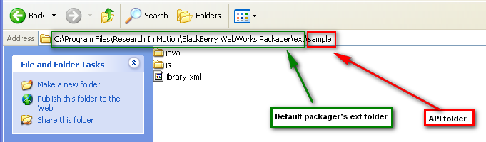
The test application contains the test page built above, the icon file and the config.xml application descriptor and it will be placed in a folder of our choosing:
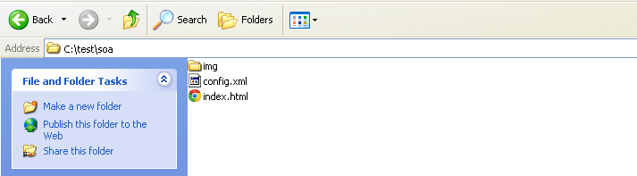
The two pieces are separate because the API can be used my multiple applications and it should be available to the packager.
The config.xml is shown below. We will highlight the key relationships between it and the library.xml. For in-depth information, please refer to the WebWorks Development Guide (http://docs.blackberry.com/en/developers/subcategories/?userType=21&category=BlackBerry+WebWorks+for+Smartphones).
<?xml version="1.0" encoding="UTF-8"?>
<widget xmlns="http://www.w3.org/ns/widgets" xmlns:rim="http://www.blackberry.com/ns/widgets" rim:header="RIM-Widget:rim/widget">
<name>SOA Sample</name>

<description>Sample SOA extension highlighting the basic components</description>

<author rim:copyright="2011">Research In Motion Inc.</author>

<icon rim:hover="false" src="img/icon.png"/>
<icon rim:hover="true" src="img/icon.png"/>

<content src="index.html"/>

<feature id="blackberry.helloworld" />
</widget>
In addition, the diagram on the next page summarizes the key relationships between the four components of the extension. It can be used a quick check guide to ensure that all the pieces are correctly connected.
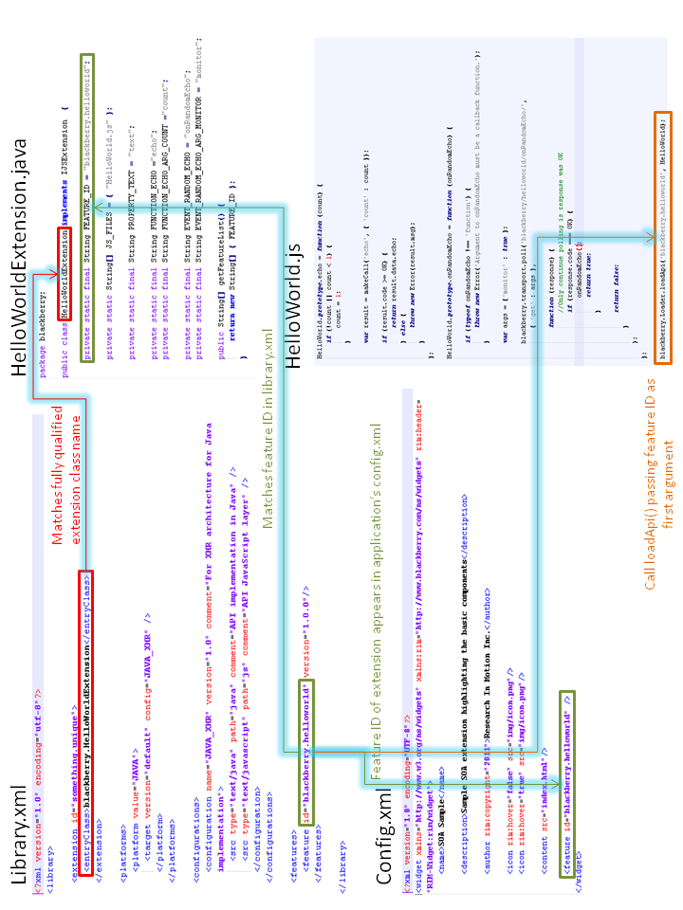
4. Implement the JavaScript layer
The JavaScript layer consists of a constructor function that will be called by the BlackBerry loader to instantiate the property.
(function () {
var OK = 0,

HelloWorld = function () {};

function makeCall(toFunction, functionArgs) {
var request = new blackberry.transport.RemoteFunctionCall('blackberry/helloworld/' + toFunction), argName;

if (functionArgs) {
for (argName in functionArgs) {
if (functionArgs.hasOwnProperty(argName)) {
request.addParam(argName, functionArgs[argName]);
}
}
}

var retVal = request.makeSyncCall();

if (retVal.code < OK) {
throw new Error(retVal.msg);
}

return retVal.data;
}

HelloWorld.prototype.__defineGetter__('text', function () {
return makeCall('text').text;
});

HelloWorld.prototype.echo = function (count) {
if (!count || count < 1) {
count = 1;
}

return makeCall('echo', { 'count' : count }).echo;
};

HelloWorld.prototype.onRandomEcho = function (onRandomEcho) {

if (typeof onRandomEcho !== 'function') {
throw new Error('Argument to onRandomEcho must be a callback function.');
}

var args = {'monitor' : true };

blackberry.transport.poll('blackberry/helloworld/onRandomEcho/',
{ 'get' : args },

function (response) {
//Only continue polling is response was OK
if (response.code === OK) {
onRandomEcho();
return true;
}

return false;
}
);
};

HelloWorld.prototype.__defineGetter__('CONSTANT', function () { return 42; });

blackberry.Loader.loadApi('blackberry.helloworld', HelloWorld);
}());
The typical pattern is to ask the loader (blackberry.loader) to attach an object that represents the structure of our API to a given namespace (blackberry.helloworld). The object passed exposes the public interface that we designed in step 1. In addition, it can have private helper functions that facilitate those calls.
The JavaScript layer makes XHR calls to the Java implementation at a URL that matches the value returned by the getFeatureList() method on the Java side. There is additional magic done on that URL by the blackberry.transport.RemoteFunctionCall() and blackberry.transport.poll() functions.
The behaviour of the onRandomEcho method has a few details to emphasize. It registers an event handler and makes long-polling calls to the Java implementation. The args object passed as an argument to the blackberry.transport.poll() function must contain a JSON structure with at least one member being “monitor”, with a Boolean value. As long as we are interested in listening for an event, monitor is true. When we wish to stop listening, we make the last polling call with monitor false.
5. Implement the Native Layer
The last step is to flesh out the native implementation of the extension in Java. This will be responsible for returning the values requested via XHR from the JavaScript layer.
The getFeatureList () method returns the feature for which the Java extension will be handling method and property calls. In our case, it returns mynamespace.helloworld. It is critical that this matches the URL to which calls are made from the JavaScript layer.
The interesting action takes place in the invoke() method. Once the framework has figured out which Java extension services a request, it will call this method with the name of the property or method and its arguments called from JavaScript. It is up to the implementation to find which method was called and service it.
The relevant information (invoked method name and parameters) is received through the request argument. Conversely, the response argument should be used by the Java implementation to pass to the framework the return data for encoding.
In the special case of event registrations, the monitor parameter will contain the Boolean value that tells the Java implementation whether it should continue listening or not.
The unloadFeatures() method should be used for general cleanup such as closing any event handling code that may be listening.
A complete code sample can be seen on the next pages.
package blackberry;

import org.w3c.dom.Document;

import net.rim.device.api.browser.field2.BrowserField;
import net.rim.device.api.script.ScriptEngine;
import net.rim.device.api.util.SimpleSortingVector;
import net.rim.device.api.web.WidgetConfig;
import net.rim.device.api.web.WidgetException;

import blackberry.common.util.json4j.JSONObject;

import blackberry.common.util.JSUtilities;

import blackberry.core.IJSExtension;
import blackberry.core.JSExtensionRequest;
import blackberry.core.JSExtensionResponse;
import blackberry.core.JSExtensionReturnValue;

public class HelloWorldExtension implements IJSExtension {

private static final String FEATURE_ID = "blackberry.helloworld";

private static String[] JS_FILES = { "HelloWorld.js" };

private static final String PROPERTY_TEXT = "text";

private static final String FUNCTION_ECHO ="echo";
private static final String FUNCTION_ECHO_ARG_COUNT ="count";

private static final String EVENT_RANDOM_ECHO = "onRandomEcho";
private static final String EVENT_RANDOM_ECHO_ARG_MONITOR = "monitor";

public String[] getFeatureList() {
return new String[] { FEATURE_ID };
}

public void loadFeature( String feature, String version, Document document, ScriptEngine scriptEngine,
SimpleSortingVector jsInjectionPaths ) {
JSUtilities.loadJS( scriptEngine, JS_FILES, jsInjectionPaths );
}

/**
* Implements invoke() of interface IJSExtension. Methods of extension will be called here.
* @throws WidgetException if specified method cannot be recognized
*/
public void invoke( JSExtensionRequest request, JSExtensionResponse response ) throws WidgetException {
String method = request.getMethodName();
Object[] args = request.getArgs();
String msg = "";
int code = JSExtensionReturnValue.SUCCESS;
JSONObject data = new JSONObject();
JSONObject returnValue = null;

try {
if( method.equals( PROPERTY_TEXT ) ) {
data.put( PROPERTY_TEXT, "Hello World" );
}else if( method.equals( FUNCTION_ECHO ) ) {
int echoCount = parseInt((String) args[ 0 ]);
data.put( FUNCTION_ECHO_ARG_COUNT, echoCount );
data.put( FUNCTION_ECHO, HelloWorldImpl.echo(echoCount) );
} else if( method.equals( EVENT_RANDOM_ECHO ) ) {
String monitor = (String) request.getArgumentByName( EVENT_RANDOM_ECHO_ARG_MONITOR );
data.put( EVENT_RANDOM_ECHO_ARG_MONITOR, monitor );

HelloWorldImpl.listenToRandomEcho(parseBoolean(monitor));
}
} catch( Exception e ) {
msg = e.getMessage();
code = JSExtensionReturnValue.FAIL;
}

returnValue = new JSExtensionReturnValue( msg, code, data ).getReturnValue();

response.setPostData( returnValue.toString().getBytes() );
}

private static boolean parseBoolean( String str ) {
return ( str != null && //undefined
str.length() > 0 && //""
!str.toLowerCase().equals( Boolean.FALSE.toString().toLowerCase() ) && //FALSE and false
!str.equals("0") && //0
!str.equals("null")); //null, NaN
}

private static int parseInt( String str ) {
if (str != null){
return Integer.parseInt(str);
}
return 0;
}

public void register( WidgetConfig widgetConfig, BrowserField browserField ) {
}

public void unloadFeatures() {
}
}
package blackberry;

import java.util.Random;

import net.rim.device.api.ui.UiApplication;
import net.rim.device.api.util.StringUtilities;

public class HelloWorldImpl {

private static Runnable _randomEchoEvent;
private static Object _randomEchoEventLock = new Object();
private static boolean _isListening = false;

{
_randomEchoEvent = new Runnable() {
public void run() {
HelloWorldImpl.onRandomEchoEvent();
}
};
UiApplication.getUiApplication().invokeLater(_randomEchoEvent, (new Random()).nextInt(), true);

}

static void onRandomEchoEvent(){
if(_isListening){
synchronized (_randomEchoEventLock) {
_randomEchoEventLock.notify();
}
}
}

public static void listenToRandomEcho(boolean enable) throws Exception{
if(enable && !_isListening){
_isListening = true;

//Blocking wait until the event actually happens
//Keeps the request open until the event
synchronized (_randomEchoEventLock) {
_randomEchoEventLock.wait();
}

//Checks whether we were notified by the event or the removal of a monitor
if(!_isListening){
throw new Exception( "Random Echo Event no longer monitored" );
}

}else if(!enable && _isListening){
_isListening= false;
synchronized (_randomEchoEventLock) {
_randomEchoEventLock.notify();
}
}
}

public static String echo(int count){
StringBuffer resultBuffer = new StringBuffer("Hello World");
StringBuffer helloWorldBuffer = new StringBuffer("Hello World");

for(int i=1;i<count;i++){
resultBuffer.append(' ');
StringUtilities.append(resultBuffer, helloWorldBuffer);
}

return resultBuffer.toString();
}
}

